Customer Portal & Admin Panel Requirements

1. Customer Login

Login Features
- Customer login should be password-based only.
- Include Forgot Password functionality.
- Include Remember Me option.
- Customer login credentials (Login ID & Password) should be visible to the admin under the customer's account settings.

2. Admin Panel Changes

Customer Account Settings
Add a new dropdown/menu named Account Settings under each customer account with the following features:

Account Management
- View customer Login ID and Password.
- Activate/Deactivate customer account.
- Assign Account Manager.
- Set Wallet Credit Limit.
- Select Payment Type:
  - Cash
  - Credit
  - Cargo
  - COD
  - RTO

KYC Management
- View customer KYC.
- Approve KYC.
- Reject KYC.
- Download completed KYC details in Excel format.

AWB Management
- Allocate AWB stock range to customers.
- Example:
  - UWC000001 to UWC000300

Customer Reference Details
Display:
- Pickup Address
- Email
- Phone Number

- 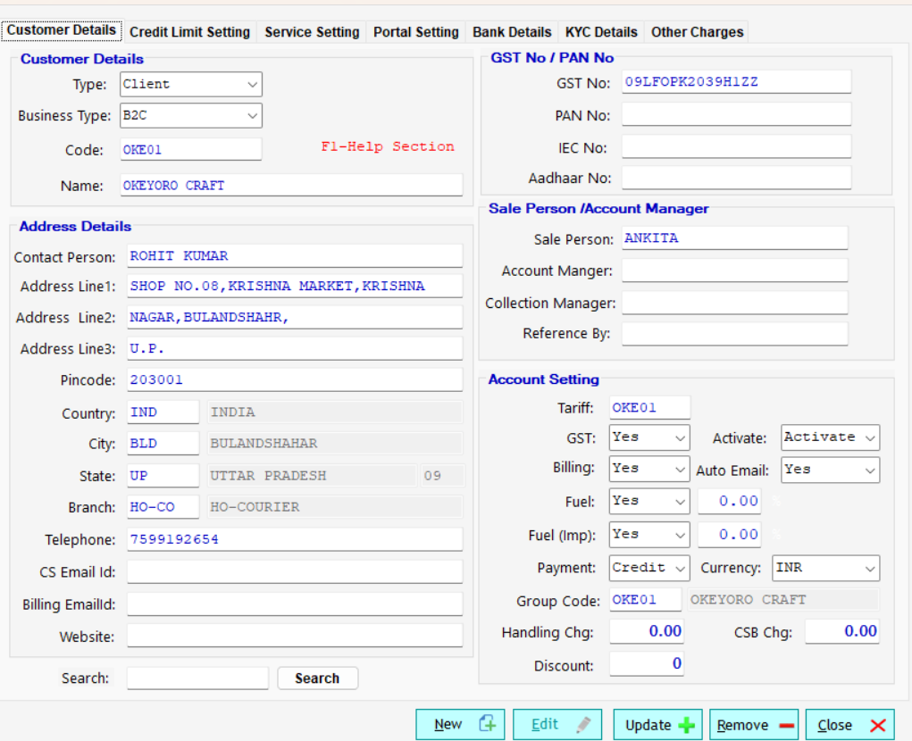
- Use this information for refence – pick up address- email,phone number
- 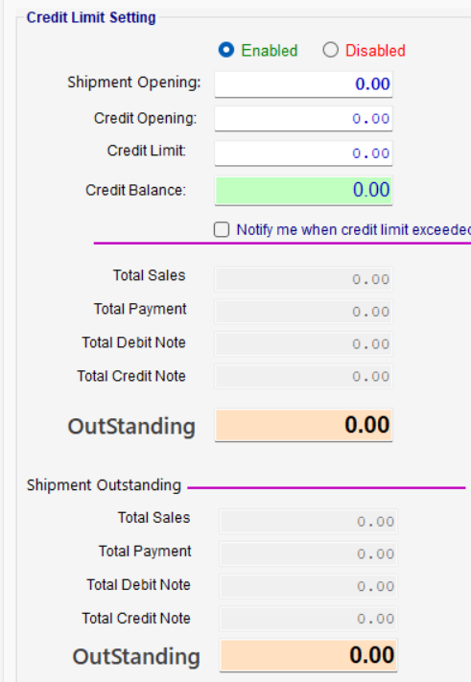

3. Customer Registration (Create Account)

Registration Page Changes
- Replace Business Account with Create Account.
- Show password with an Eye (Show/Hide Password) icon.
- Remove Aadhaar Number field from registration.
- Add Mobile Number with OTP Verification.
- Provide two account options:
  - Personal
  - Business

Business Account Categories
When Business is selected, display:
- Exporter
- E-commerce
- Courier/Aggregator

Terms & Conditions
Display the following statement before account creation:
"By clicking Create Account, you agree to United Worldwide Courier's Terms & Conditions and Privacy Policy."

Merchant Agreement Popup
After successful registration and before KYC begins, display a popup containing the Merchant Agreement. The customer must accept the agreement before proceeding with KYC.

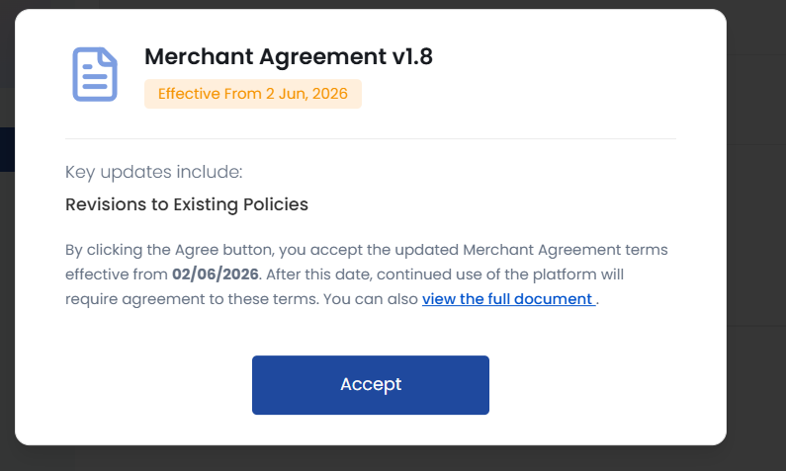

4. Personal KYC (CSB-IV)
The Personal KYC process should include:

Aadhaar Verification
- Aadhaar Number
- Upload Aadhaar (front and back)
- Verify Aadhaar

PAN Verification
- PAN Number
- PAN Holder Name
- Date of Birth
- Upload PAN
- Verify PAN

Signature
- Upload Signature

KYC Summary
After successful completion, customers should be able to view all submitted KYC details.
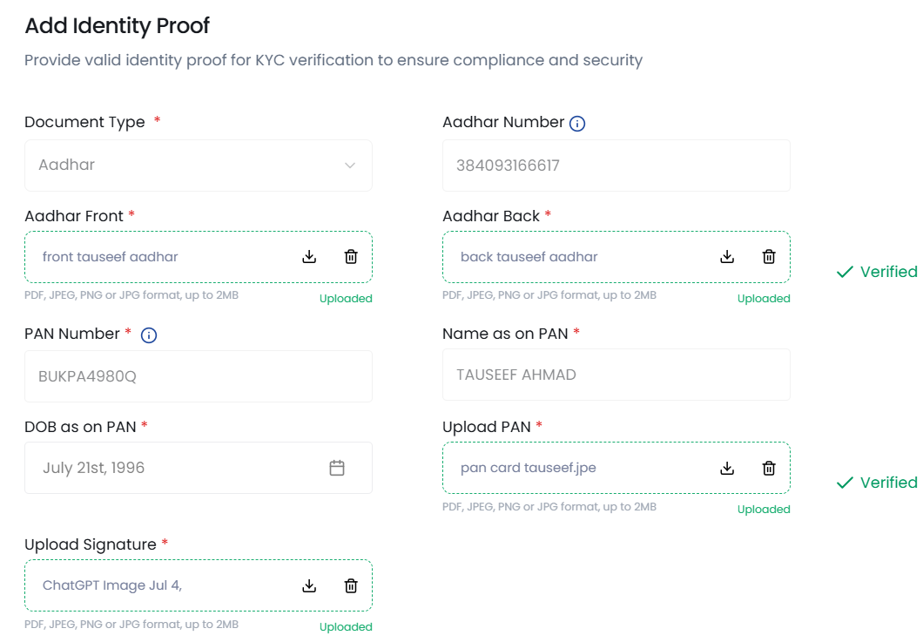
- After kyc is complte everything is upload. Customer should see these details. 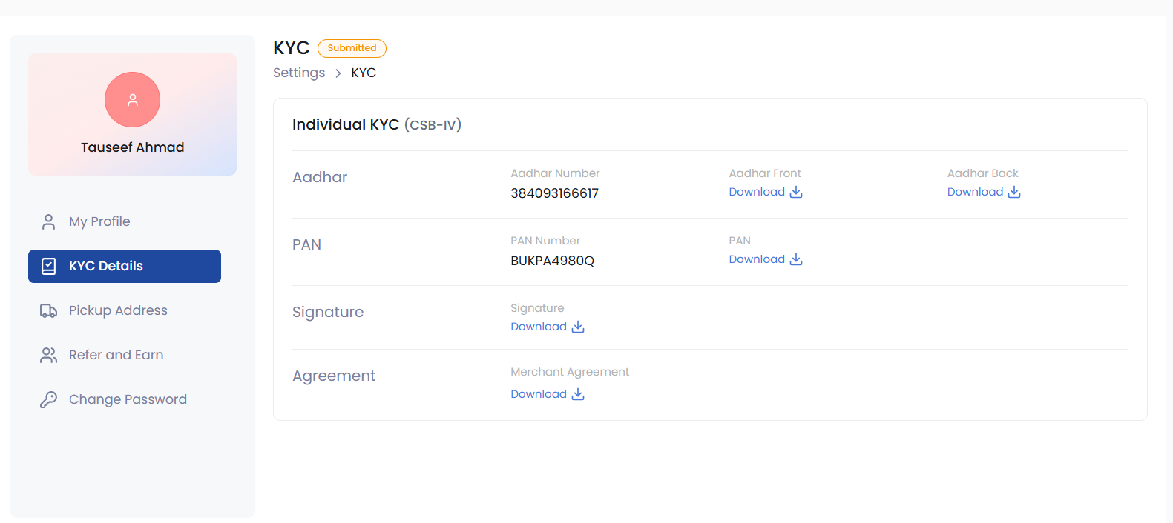

5. Business KYC (CSB-V)
The Business KYC process should include:

Aadhaar
- Aadhaar Number
- Upload Aadhaar
- Verify Aadhaar

GST
- GST Number
- Upload GST Certificate
- Verify GST

Signature
- Upload Authorized Signature with Company Stamp

IEC
- IEC Number
- Upload IEC Certificate

AD Code
- Upload AD Code Document

LUT
- LUT Expiry Date
- Bond Year
- Upload LUT Document

Banking Details
- Bank Category:
  - Public Bank
  - Private Bank
- Bank Account Number

Billing Details(billing address firm via gst)
- Billing Information

Agreement
- Upload signed Merchant Agreement with company stamp and signature.

6. Customer Dashboard
Once KYC is completed, customers should be able to:
- View all submitted KYC details.
- View uploaded documents.
- Check KYC approval status (Pending / Approved / Rejected).

7. Admin Workflow
The admin should be able to:
- View customer profile.
- View login credentials.
- Review KYC documents.
- Approve or reject KYC.
- Download KYC records in Excel.
- Activate or deactivate customer accounts.
- Assign account managers.
- Configure wallet credit limits.
- Configure payment types.
- Allocate AWB stock ranges.
- View customer contact details and pickup address.

Customer dashboard
-shipment booked
-pick up in progress
-hold shipment

Portal Weight & Dimension Validation Rules
1. Maximum Weight Limits
- Maximum Actual Weight: 30 kg
- Maximum Volumetric Weight: 40 kg (without oversize charges)
2. Dimension Limits
- Maximum Length: 120 cm
- Maximum Width: 76 cm
- Height: Flexible (no restriction)
3. Oversize Shipment Validation
If the Volumetric Weight falls between 40.001 kg and 68 kg:
- The portal should allow the shipment.
- Apply an Oversize Charge of ₹21,000 automatically.
- Display a pop-up notification before booking.
Popup Message:
Oversize Shipment Alert
This shipment exceeds the standard volumetric weight limit (40 kg).
- Volumetric Weight: 40.001 kg – 68 kg
- Oversize Charge: ₹21,000 will be applicable.
For further assistance, please contact your Sales Representative before proceeding.
(Include an Information (ℹ️) icon in the popup.)

4. USA – United Ground Premium Handling Charges
For shipments booked under USA (United Ground Premium):
- If Actual Weight > 22 kg
- Automatically add a Handling Charge of ₹5,000.
Rule:
Service: USA – UNITED GROUND PREMIUM
If Actual Weight > 22 kg
→ Add Handling Charge = ₹5,000

Summary of Business Rules
Condition | Action
Actual Weight ≤ 30 kg | Allow booking
Actual Weight > 30 kg | Reject booking / Not Allowed
Volumetric Weight ≤ 40 kg | Standard Rates
Volumetric Weight 40.001–68 kg | Add ₹21,000 Oversize Charge + Show Popup
Volumetric Weight > 68 kg | Reject booking / Contact Sales
Length > 120 cm | Reject booking / Contact Sales
Width > 76 cm | Reject booking / Contact Sales
Height | No Restriction
USA – United Ground Premium & Actual Weight > 22 kg | Automatically add ₹5,000 Handling Charge

